Lab 11 – My Solutions
1: Automated Software Deployment and Configuration:
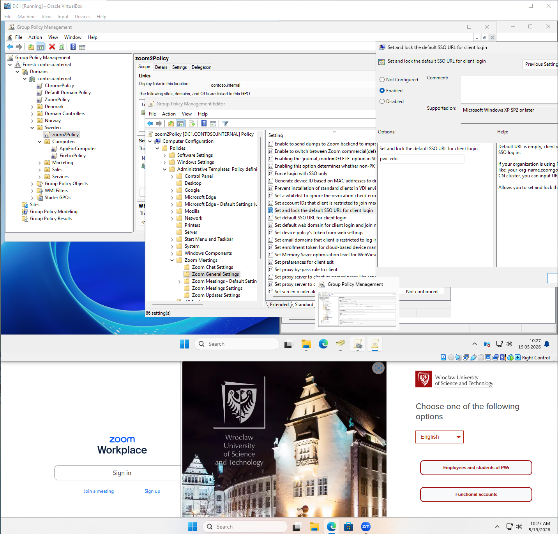
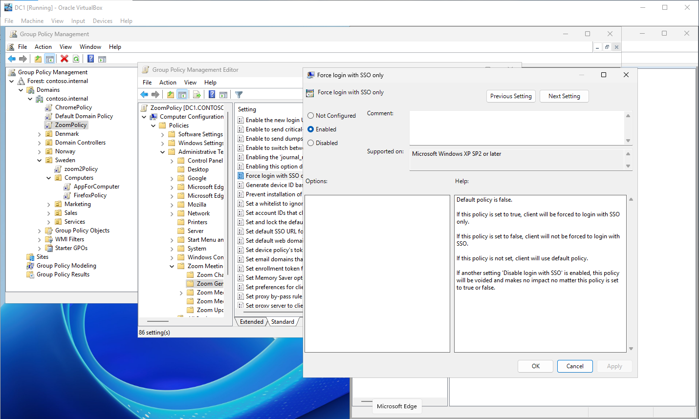
2: User Environment Automation (Logon Scripting):

3: Password Policy Segmentation:

4: Policy Diagnostics, Simulation, and Verification:

